**Set Up JDBC Environment(unassisted)**

**Creating a Table in Database**

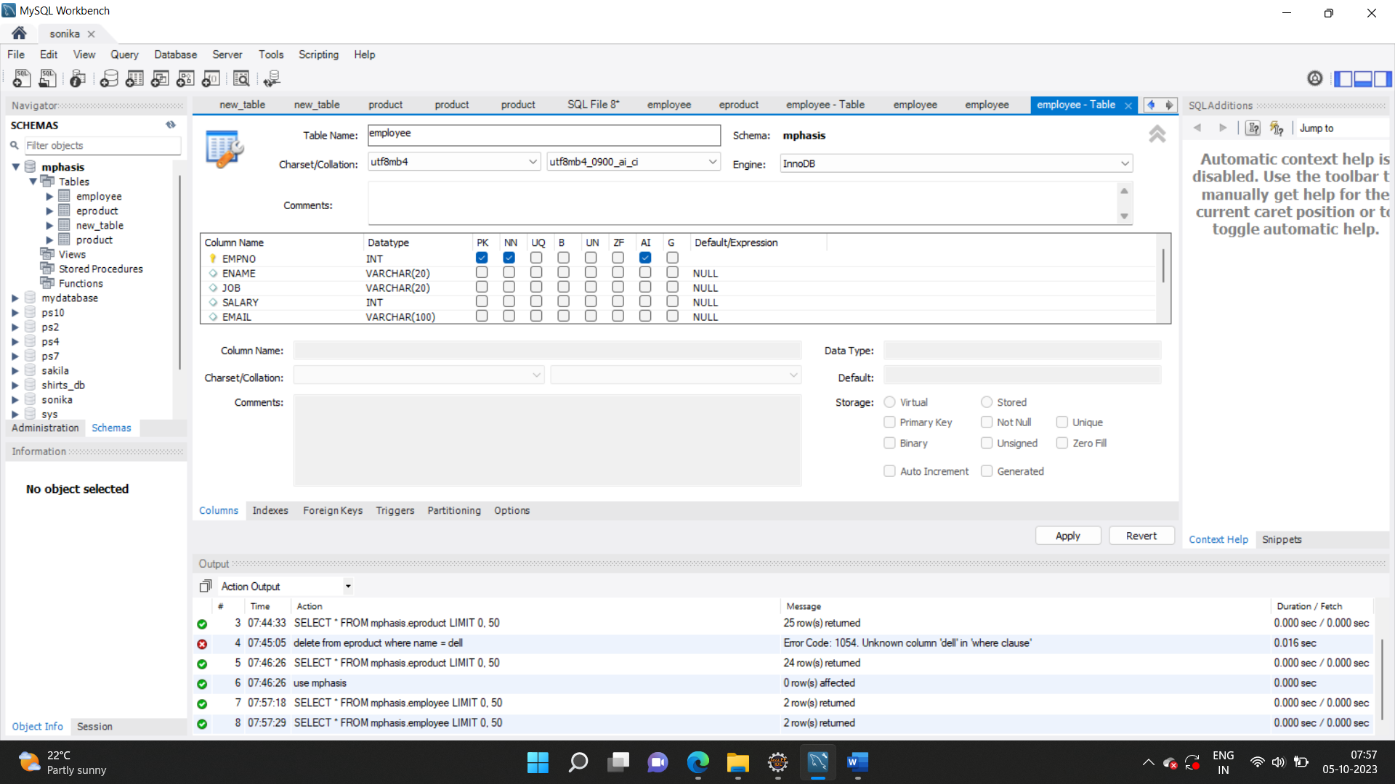

Create HTML Page

<!DOCTYPE html>

<html>

<head>

<meta charset="ISO-8859-1">

<title>Insert title here</title>

</head>

<body>

<h1 style ="text-align: center;width: 100%;">

ADD NEW EMPLOYEE

</h1>

<form method = "post" action="AddEmp">

<table width ="50%" border="1">

<tr>

<td>Employee Name</td>

<td>

<input type = "text" name ="txtEname"/>

</td>

</tr>

<tr>

<td>Job</td>

<td>

<input type = "text" name ="txtjob"/>

</td>

</tr>

<tr>

<td>Salary</td>

<td>

<input type = "text" name ="txtsalary"/>

</td>

</tr>

<tr>

<td>Email</td>

<td>

<input type = "text" name ="txtemail"/>

</td>

</tr>

<tr>

<td>pswd</td>

<td>

<input type = "text" name ="txtpswd"/>

</td>

</tr>

<tr>

<td>

<input type ="submit" value ="Add Employee"/>

</td>

<td>

<input type = "reset" name ="Clear Form"/>

</td>

</tr>

</table>

</form>

</body>

</html>

Create Connection class

package com.connect;

import java.sql.*;

public class DbConnection {

public static Connection getConnection()

{

Connection con = null;

try

{

Class.*forName*("com.mysql.cj.jdbc.Driver");

con = DriverManager.*getConnection*("jdbc:mysql://localhost:3306/mphasis", "root", "sonika");

}

catch(Exception ex)

{

System.***out***.println(ex);

}

return con;

}

}

Create Servlet Page

import java.io.IOException;

import java.io.PrintWriter;

import javax.servlet.ServletException;

import javax.servlet.annotation.WebServlet;

import javax.servlet.http.HttpServlet;

import javax.servlet.http.HttpServletRequest;

import javax.servlet.http.HttpServletResponse;

import java.sql.*;

import com.connect.*;

/**

* Servlet implementation class AddEmp

*/

*@WebServlet*("/AddEmp")

public class AddEmp extends HttpServlet {

private static final long ***serialVersionUID*** = 1L;

/**

* **@see** HttpServlet#HttpServlet()

*/

public AddEmp() {

super();

// **TODO** Auto-generated constructor stub

}

/**

* **@see** HttpServlet#service(HttpServletRequest request, HttpServletResponse response)

*/

protected void service(HttpServletRequest request, HttpServletResponse response) throws ServletException, IOException {

response.setContentType("text/html");

PrintWriter out = response.getWriter();

String ename= request.getParameter("txtEname");

String job= request.getParameter("txtjob");

String salary= request.getParameter("txtsalary");

String email= request.getParameter("txtemail");

String pswd= request.getParameter("txtpswd");

try {

Connection conObj = DbConnection.*getConnection*();

PreparedStatement ps = conObj.prepareStatement("Insert into Employee(ename, job, salary, email, pswd) values(?,?,?,?,?)");

ps.setString(1, ename);

ps.setString(2, job);

ps.setInt(3, Integer.*parseInt*(salary));

ps.setString(4, email);

ps.setString(5, pswd);

int res = ps.executeUpdate();

//if(res>=1) {

//response.sendRedirect("ViewAllEmps");

out.print("<h1>Employee is Added....</h1>");

// }

}

catch(Exception e ) {

}

}

protected void doGet(HttpServletRequest request, HttpServletResponse response) throws ServletException, IOException {

// **TODO** Auto-generated method stub

response.getWriter().append("Served at: ").append(request.getContextPath());

}

/**

* **@see** HttpServlet#doPost(HttpServletRequest request, HttpServletResponse response)

*/

protected void doPost(HttpServletRequest request, HttpServletResponse response) throws ServletException, IOException {

// **TODO** Auto-generated method stub

doGet(request, response);

}

}

Add Servlet jar :

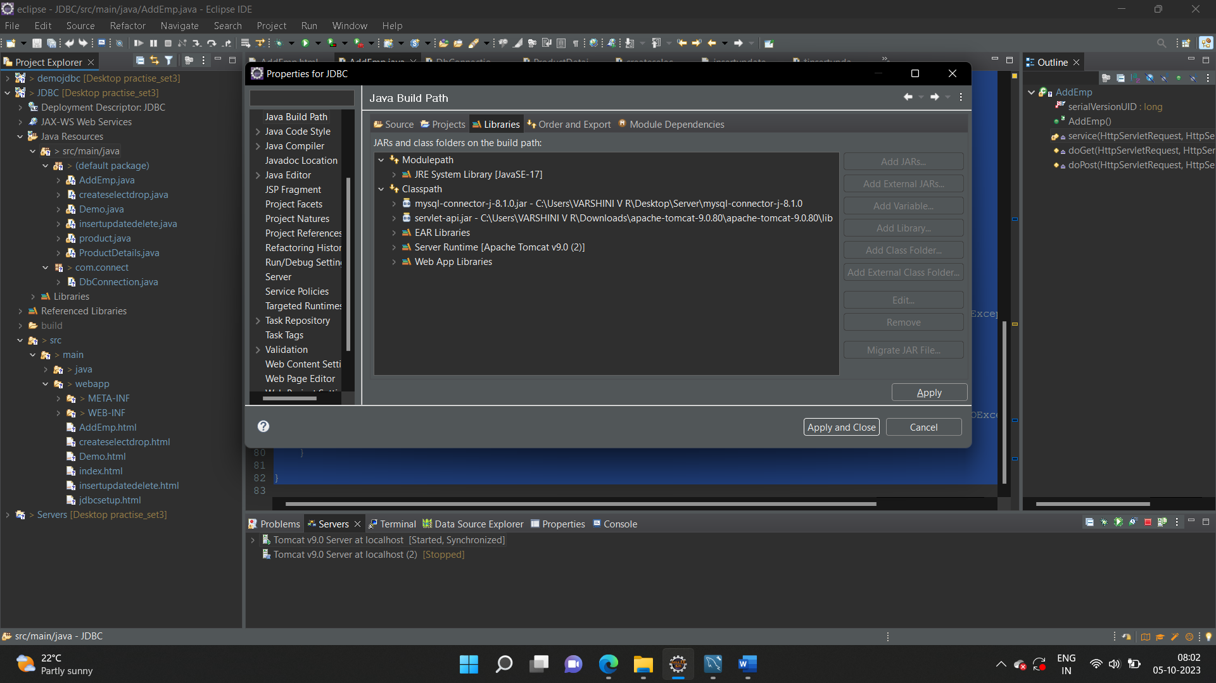



Add SQL Connector Jar

